Attendance Tracker Program

Setup and Configuration

Written by: Clifford Dela Cruz

**Background**

This system is designed for use within a church to efficiently track member attendance. It is intended to address several challenges faced by the ushers and the hospitality ministry, including:

1. **Accurate Record Keeping:** Effectively capturing and storing attendance data for each service.
2. **Follow-up Identification:** Easily identifying members who may require further follow-up or care.
3. **Data Integrity:** Producing a clean, duplicate-free list of members for administrative use.

**Setup instructions:**

1. Create a google spreadsheet and follow the “Attendance Tracker” spreadsheet that should be included in this guide.
2. Save the google spreadsheet in google drive
3. Go to extensions 🡺 Apps Script

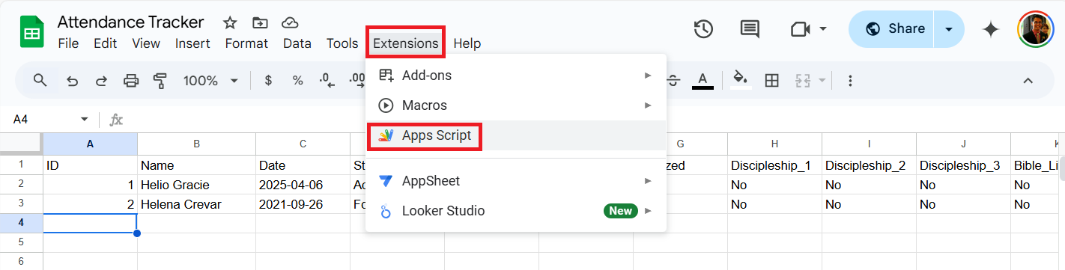

1. Create the script, front end (HTML), css (optional)

Code.gs – stores the javascript

Index.HTML – front end

Styles.CSS – CSS to style the front end

1. Deploy by selecting ‘Deploy’ 🡺 ‘New Deployment’

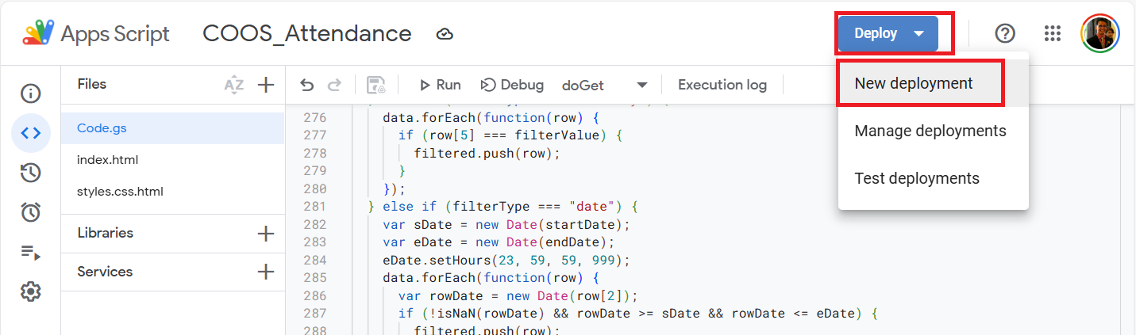

URL will be provided to access the front end.

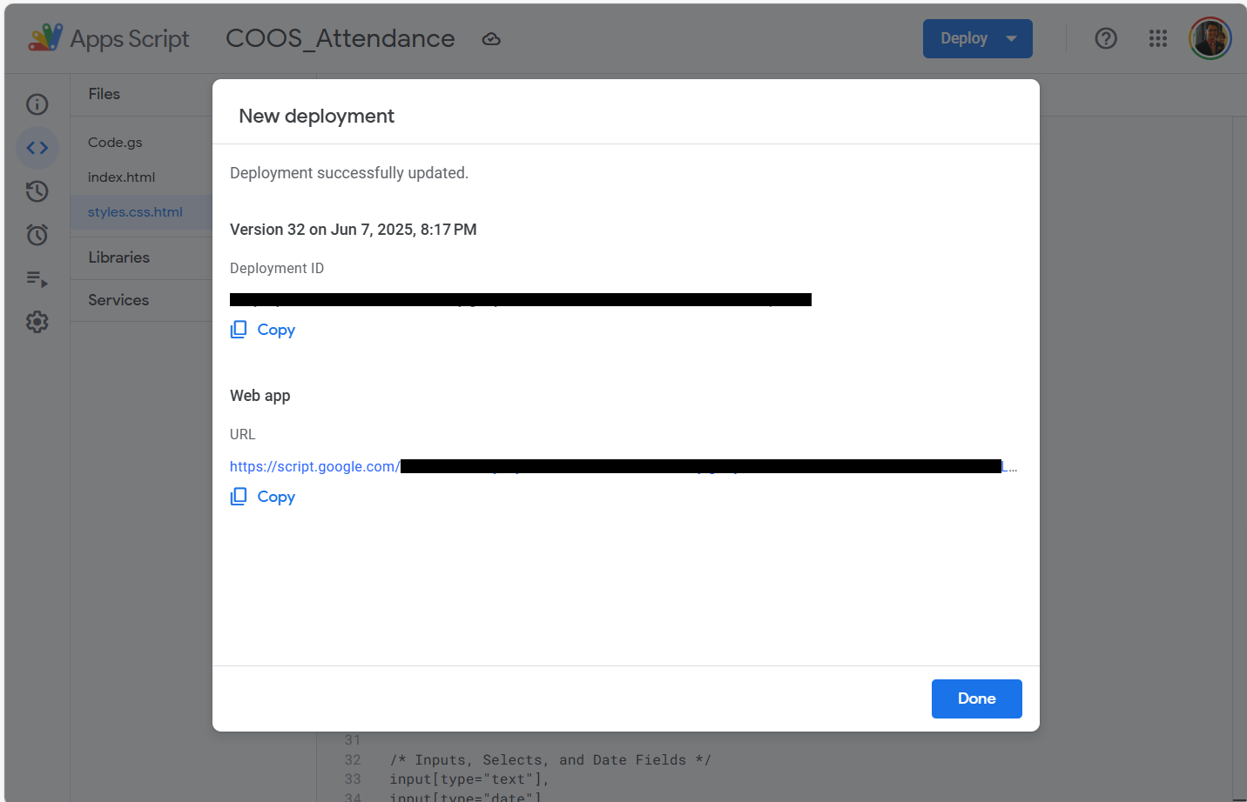

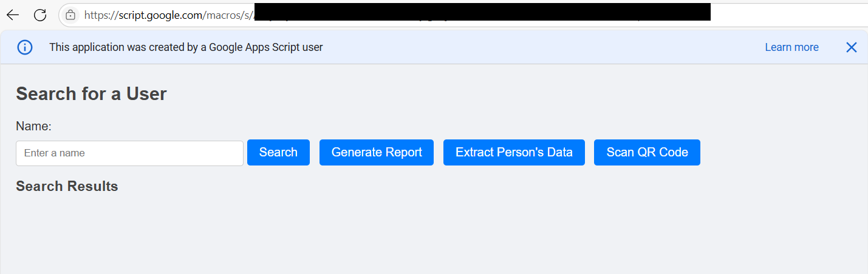

**Things to take note:**

1. For “Attendance Tracker” spreadsheet
2. “Person_Master” – stores the members non-sensitive information (name, cell group, ministry, if baptized, if attended discipleship class, if attended Bible literacy program, if attended Financial Literacy program, if attended teaching class and the last attended church service

1. “Attendance_Table” – stores member’s name and date attended

1. “Cell_Group_Master” – contains cell group name and its PIC. This list is used to display data in “Cell Group” drop down list

1. “Ministry_Master” – contains ministry name and its PIC. This list is used to display data in “Ministry Master” drop down list

